Manual for January Font

Brief Intro
January is a geometric–humanist sans-serif font.
The current version is 1.1.0.

License
© 2018 – 2019, Flora Canou (floracanou@qq.com)
This Font Software is licensed under the SIL Open Font License, Version 1.1.
You should have received a copy of the license text. If not, see here.

Credits
Key Authors:
– Flora Canou
Special Thanks:
– Pablo Impallari
– Vernon Adams

Glyph Coverage
Currently, the repertoire fully covers Latin-1 and Latin Extended-A.
Note that the font targets Latin, Greek and Cyrillic scripts. Characters outside the scope are unlikely to be added in the future.

List of OpenType Features
ID | * | Applied Characters | Description
kern | 1 | † | Kerning
dlig | 0 | ff, fff, tt, ttt, tz | Discretionary ligatures
smcp | 0 | Lowercase letters (incomplete) | Small capital
c2sc | 0 | Uppercase letters (incomplete) | Small capital
sups | 0 | Numerals and letters (incomplete) | Superscript
subs | 0 | Numerals and letters (incomplete) | Subscript
cv01 | 0 | I and its derivatives (notably ɪ) | With cross bars
cv02 | 0 | J and its derivatives | With cross bars
cv05 | 0 | f and ſ | With low hook
ss01 | 0 | a and its derivatives | Double-storey
ss03 | 0 | j, l, t and their derivatives | Straight tail
ss04 | 0 | All characters with cedilla | Turn cedillas to commas
* Default Value
† To view the kerning table, please check the source code.

How to access OpenType Features in LibreOffice
Where you pick a font, type a colon (U+003A) following the font name. Add the desired feature ID listed above (first column) followed by an equal sign (U+003D) and the value. The equal sign and the value may be omitted, meaning the value is 1. If multiple features are desired, separate them with an ampersand (U+0026).
E.g.
January: ss01=1 or January: ss01 will turn on Stylistic Set 01.
January: kern=0 will turn off kerning.

Warning of Use of Private Code Points
It is recommended that alternate characters should be accessed through OpenType features and NOT from characters coded U+E000 – U+F800 directly because the latter is of limited interoperability.
More information

Design
The font is intended for title or short text. The design seeks to combine geometric and humanist features, inspired by Cabin by Pablo Impallari and Muli by Vernon Adams.

Dev Guide
This work is made with the free software FontForge.

See the next page for samples.
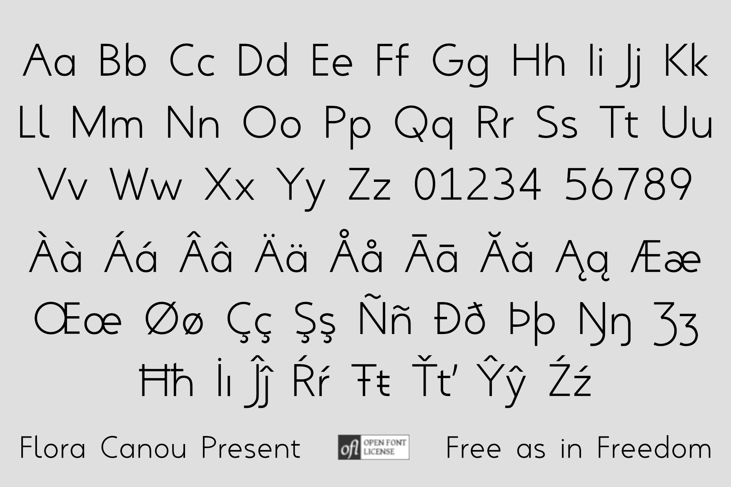
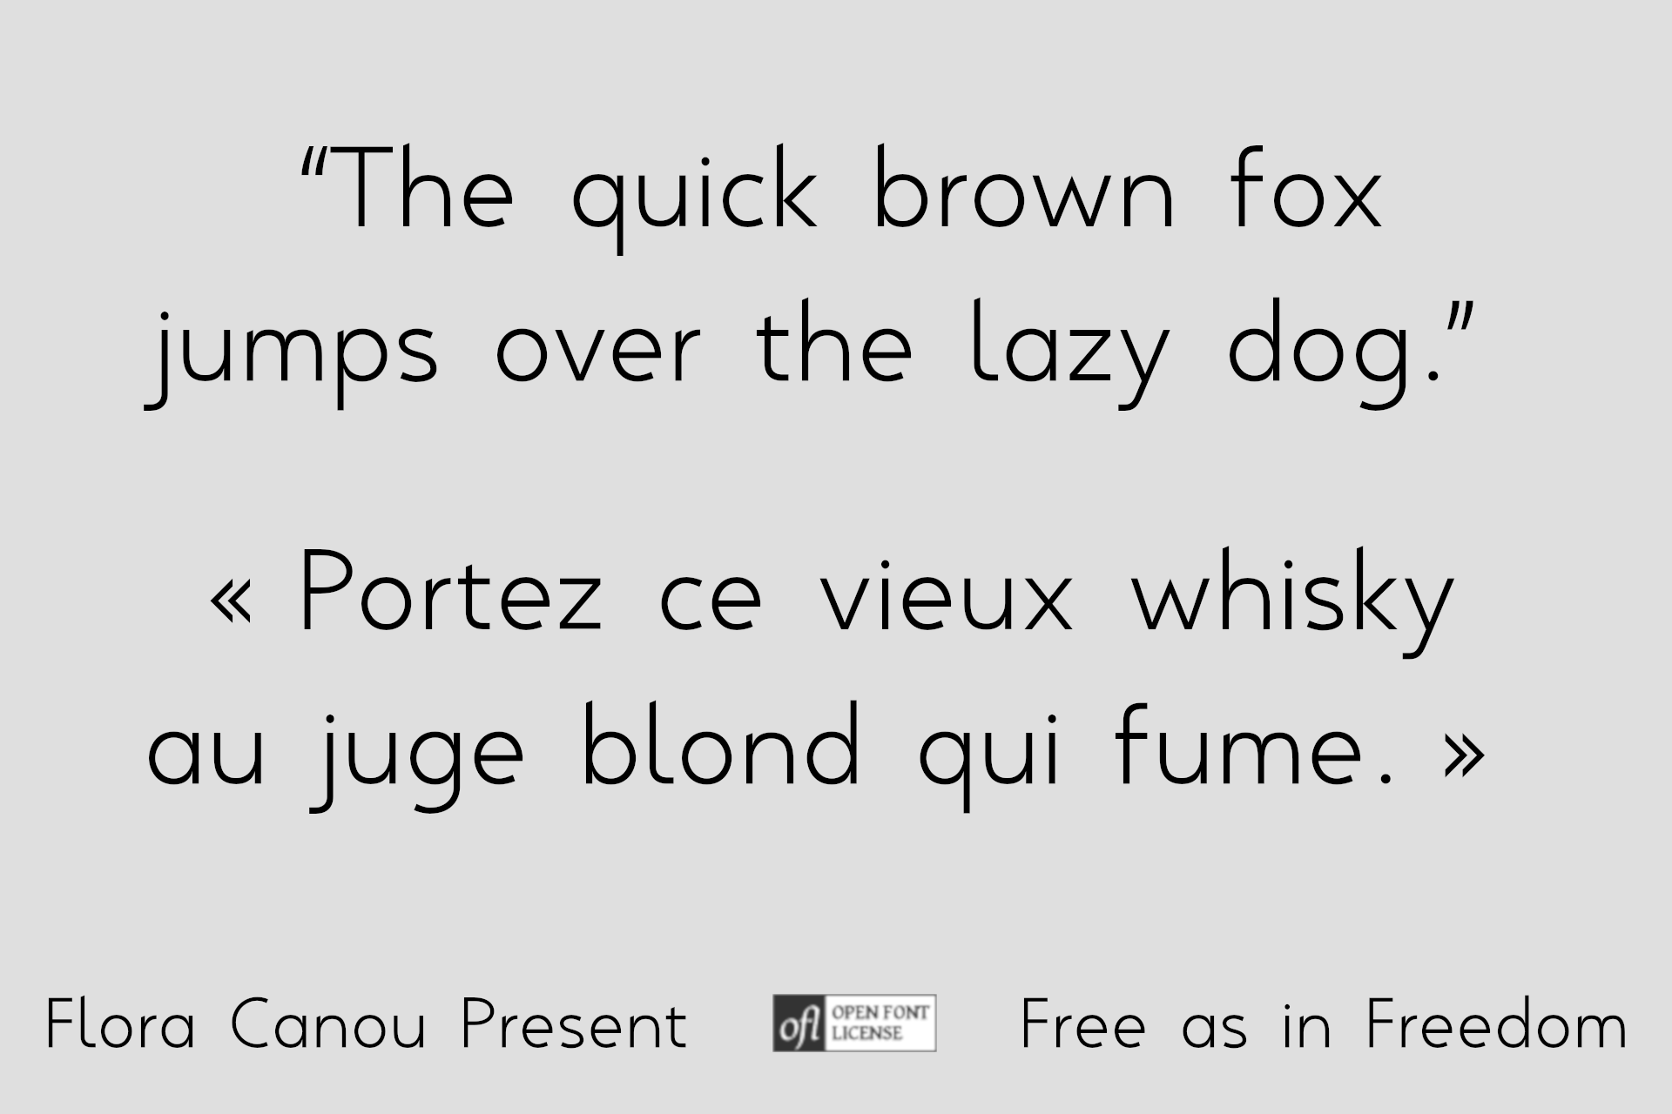
Above: Individual letters
Below: Text
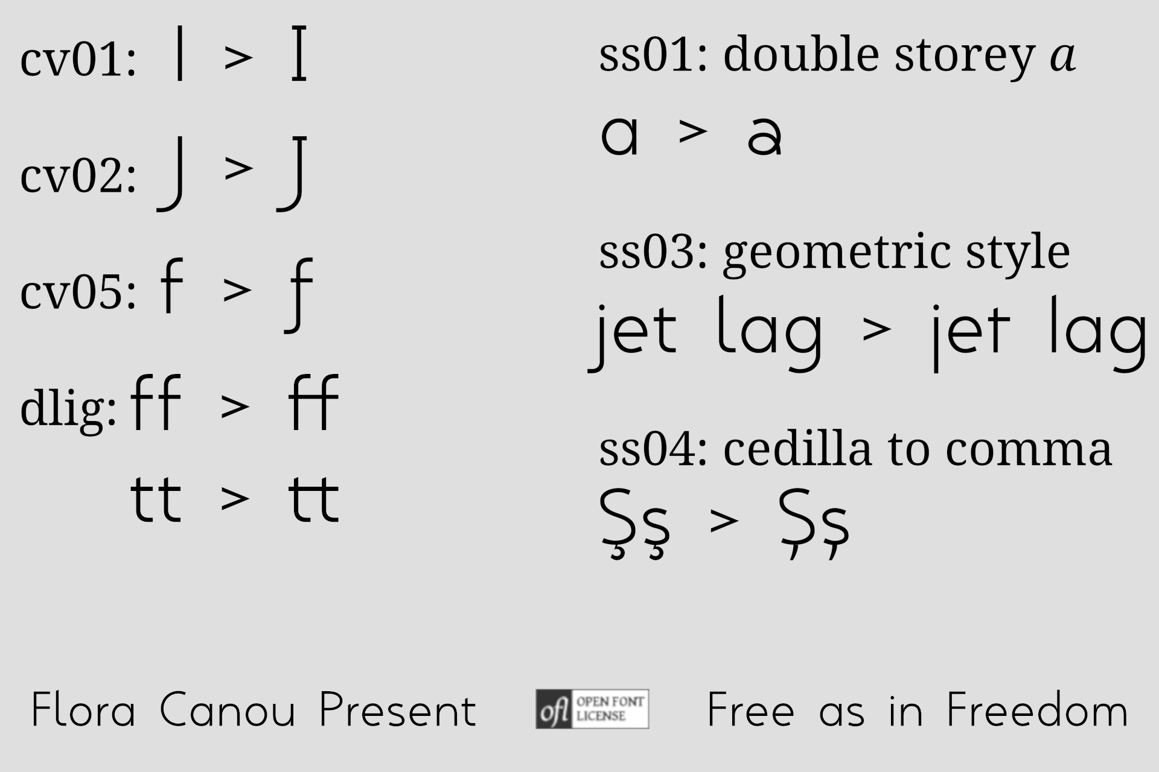
Above: OpenType features

